Introduction | My Creations | Future Development
Download
Kelvin: The Chosen One

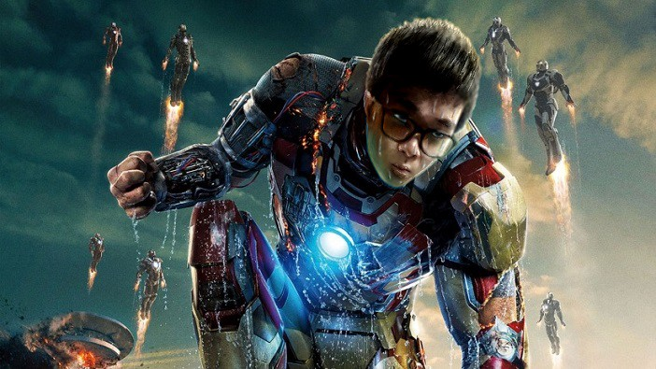

Introduction

Brief Information
My name is Kelvin and I am 20 years old. I like drawing and playing computer games. I also love playing music instruments such as piano and drums. I learnt Taekwondo before and my hobby is solving rubic's cubes.

About my education background, I studied at S.K.H. Lam Kau Mow Secondary School for 6 years. I am studying at Caritas Institude of High Education now.
My career objectives are to create my own computer game, and to draw my own manga. Then release them to the public to allow people to enjoy.

Thankful People

I would like to give thanks to three thankful people in my life, as they helped me so much in my career.

My Mother My Father
My Career Teacher

My Creations

Drawing

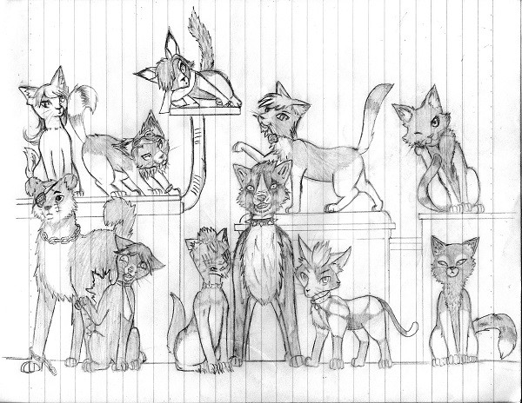
I draw a lot since I was small. Here is one of my favourite drawing which consists of many adorable animals.

I also like to draw mangas, below shows some of my creations.
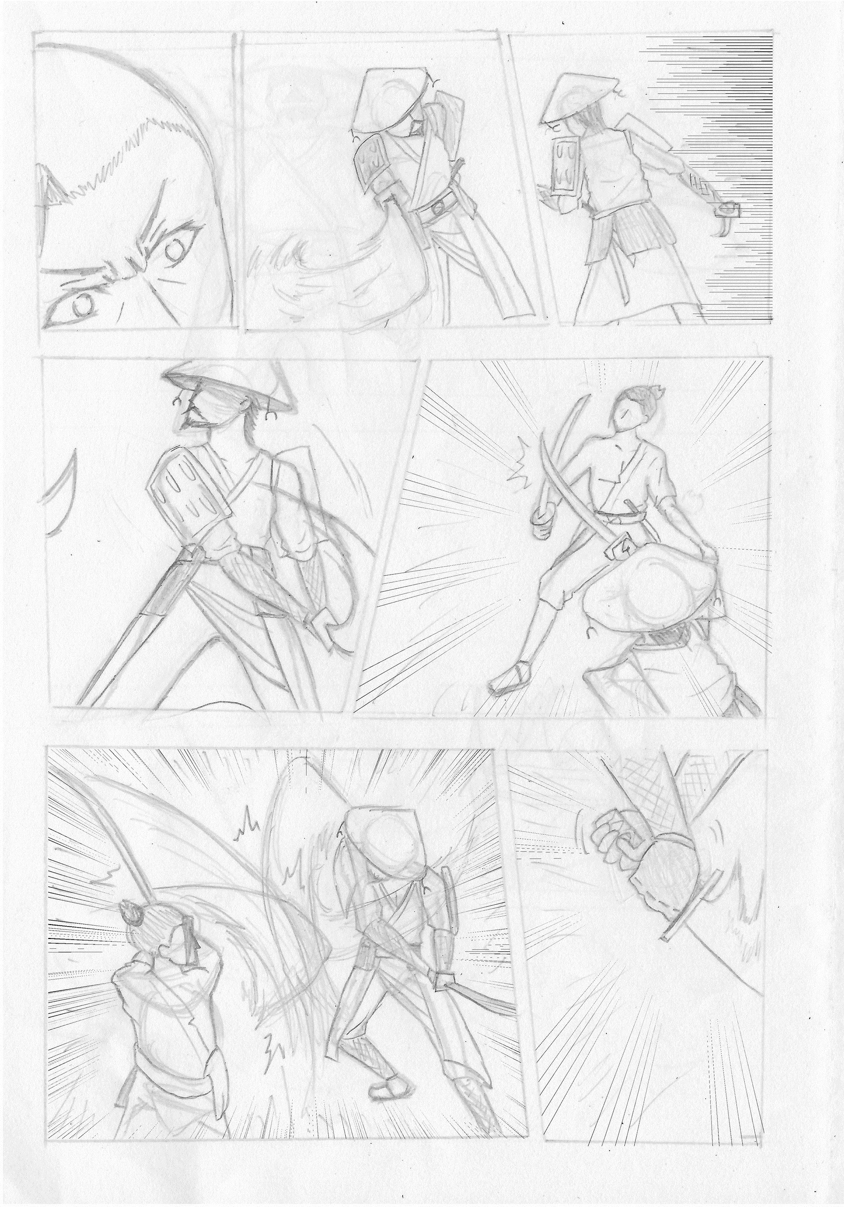
Draft
Colored
Black & White

Animation

This is a stickman fighting animation named "The Flash" which I created when I was in secondary school. It is my first animation done so it was not good in quality

Actually I started working on it right after I graduated from primary school. I uploaded the animation to my Facebook page when it is completed.

I like stickman animation since I was small and that's the reason I create stickman animations. There are some more similar animations created by me too.
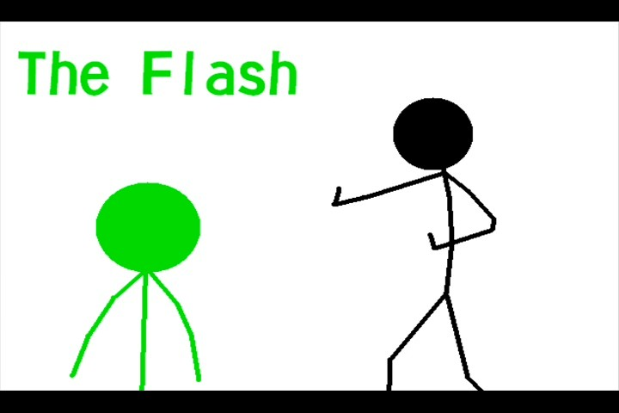

0:00 / 3:14

Music
As there are drawings and animations. I also attempted to create musics for my creations, here is one example.

0:
00
/ 1:56

Future Development

Desired Jobs
These are my desired jobs which I hope I can apply in my career.

- Game Designer
- Artist

- Band Member

Contact Me
If you share the same interestes or hobbies with me, feel free to contact me to cooperate on interesting projects!

Contact Form First Name: Last Name:
E-mail:

Telephone: (format:1234-5678)

Submit Reset

Download

If you encounter any problem reading this webpage or you want to save this webpage. You can download the webpage as different formats.

Word Version

Download the Word version.

PDF Version

Download the PDF version.

